**Create a React Application named “cricketapp”**

**App.js**

import React from 'react';

import ListOfPlayers from './ListOfPlayers';

import IndianPlayers from './IndianPlayers';

function App() {

  const flag = false;

  return (

    <div>

      <h1>React App</h1>

      {flag ? <ListOfPlayers /> : <IndianPlayers />}

    </div>);

}

export default App;

**ListOfPlayers.js**

import React from 'react';

function ListOfPlayers() {

  const players = [

    { name: 'Jack', score: 50 },

    { name: 'Michael', score: 70 },

    { name: 'John', score: 40 },

    { name: 'Ajin', score: 61 },

    { name: 'Elisabeth', score: 61 },

    { name: 'Sachin', score: 95 },

    { name: 'Dhoni', score: 100 },

    { name: 'Virat', score: 84 },

    { name: 'Jadeja', score: 64 },

    { name: 'Raina', score: 75 },

    { name: 'Rohit', score: 80 },

  ];

const players70 = [];

  players.map((item) => {

    if (item.score <= 70) {players70.push(item);}

  });

  return (

    <div>

      <h2>List of Players</h2>

      {players.map((item, index) => {

        return (

          <div key={index}>

            <li>Mr. {item.name}: <span> {item.score} </span></li>

          </div>);

      })}

      <h3>List of Players having Scores Less than 70</h3>

      {players70.map((item, index) => {

        return (

          <div key={index}>

            <li>Mr. {item.name}: <span> {item.score} </span></li>

          </div> );

      })}

    </div> );

}

export default ListOfPlayers;

**IndianPlayers.js**

import React from 'react';

function OddPlayers({ players }) {

  const [first, , third, , fifth] = players;

  return (

    <div>

      <h2>Odd Players</h2>

      <ul>

        <li>First : {first}</li>

        <li>Third : {third}</li>

        <li>Fifth : {fifth}</li>

      </ul>

    </div>

  );

}

function EvenPlayers({ players }) {

  const [, second, , fourth, , sixth] = players;

  return (

    <div>

      <h2>Even Players</h2>

      <ul>

        <li>Second : {second}</li>

        <li>Fourth : {fourth}</li>

        <li>Sixth : {sixth}</li>

      </ul>

    </div>

  );

}

function IndianPlayers() {

  const team = ['Sachin', 'Dhoni', 'Virat', 'Rohit', 'Raina', 'Jadeja'];

  const T20Players = ['First Player', 'Second Player', 'Third Player'];

  const RanjiTrophyPlayers = ['Fourth Player', 'Fifth Player', 'Sixth Player'];

  const mergedPlayers = [...T20Players, ...RanjiTrophyPlayers];

  return (

    <div>

      <OddPlayers players={team} />

      <EvenPlayers players={team} />

      <h2>List of Indian Players Merged:</h2>

      <ul>

        {mergedPlayers.map((player, index) => (

          <li key={index}>Mr. {player}</li>

        ))}

      </ul>

    </div>

  );

}

export default IndianPlayers;

**Output**

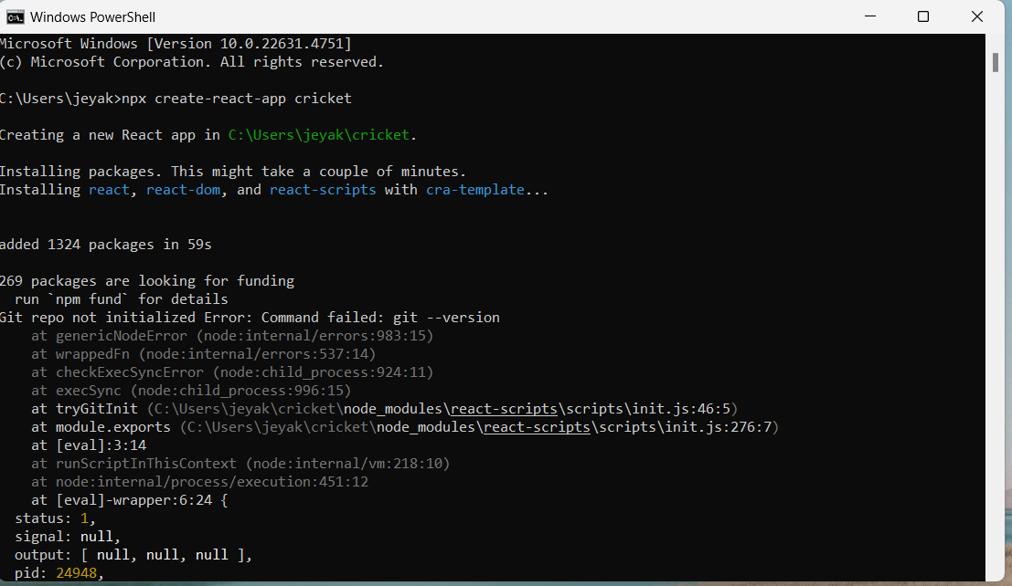

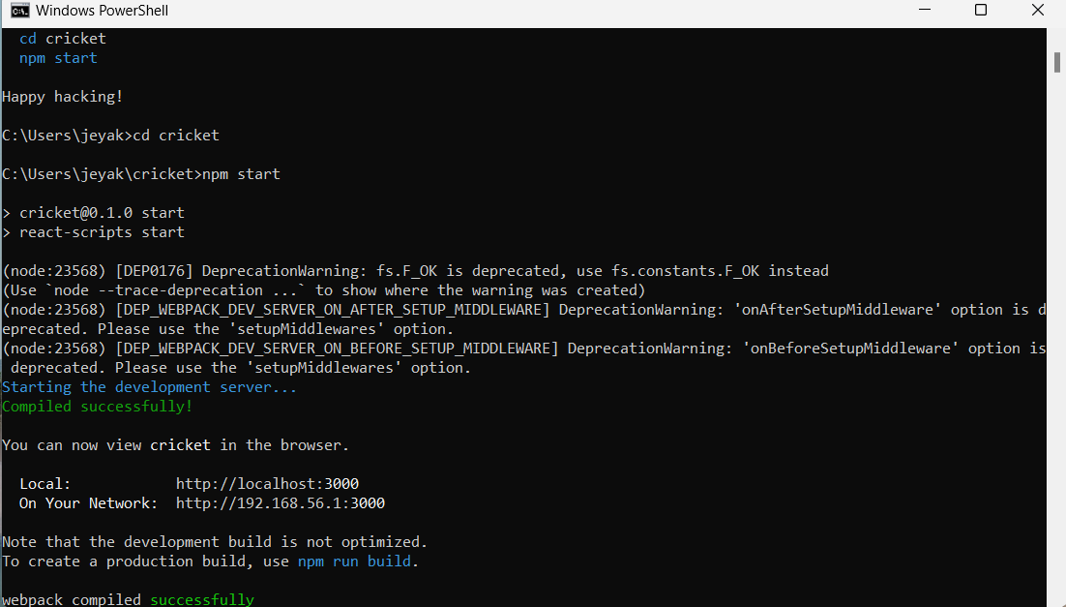

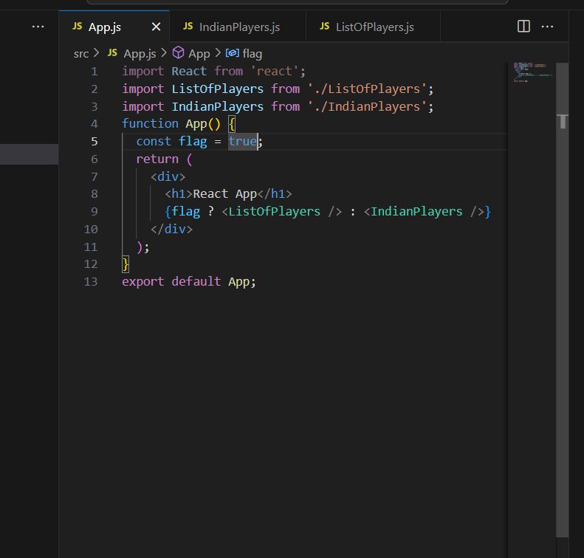

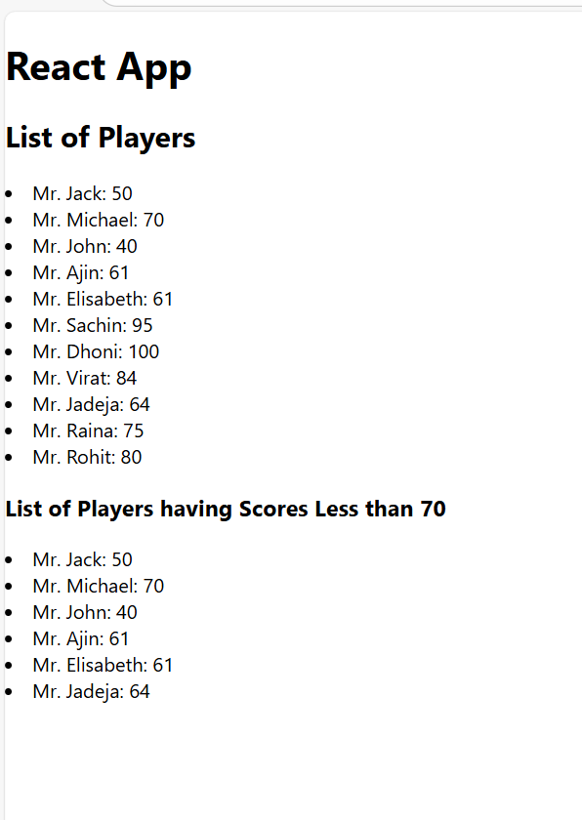

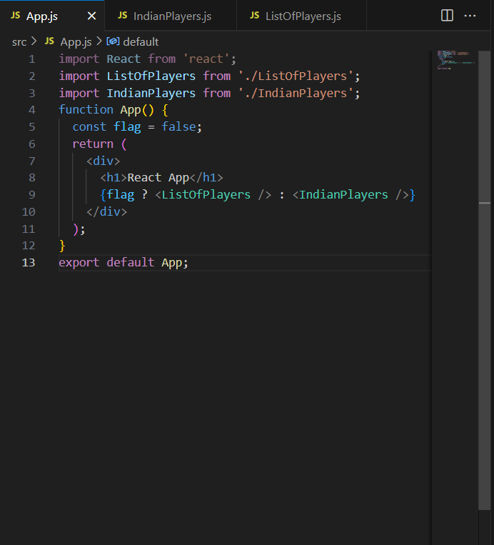

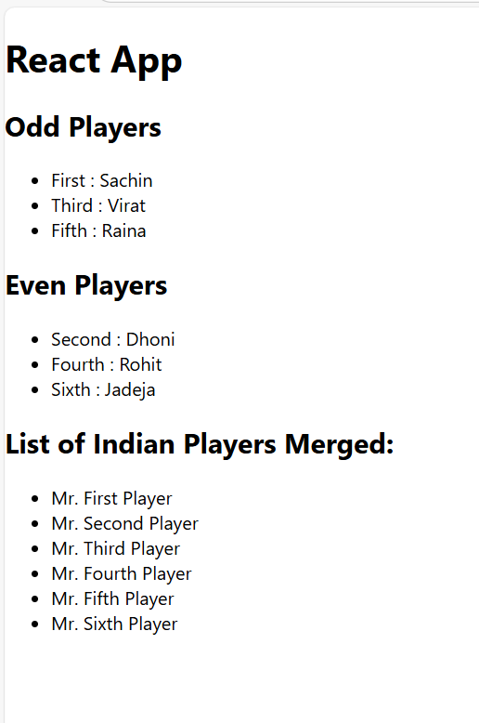

**Create a React Application named “officespacerentalapp” which uses React JSX to create elements, attributes and renders DOM to display the page.Create an element to display the heading of the page.Attribute to display the image of the office space.Create an object of office to display the details like Name, Rent and Address.Create a list of Object and loop through the office space item to display more data.To apply Css, Display the color of the Rent in Red if it’s below 60000 and in Green if it’s above 60000.**

**App.js**

import React from 'react';

function App() {

  const officeSpaces = [{

      name: "DBS",

      rent: 50000,

      address: "Chennai",

      image: "dbs.jpg" },

    {

      name: "Regus",

      rent: 75000,

      address: "Mumbai",

      image: "regus.jpg"},

    {

      name: "WeWork",

      rent: 45000,

      address: "Bangalore",

      image: "wework.jpg"} ];

  return (

    <div style={{ padding: '20px', fontFamily: 'Arial' }}>

      <h1>Office Space, at Affordable Range</h1>

      {officeSpaces.map((item, index) => {

        const rentColor = item.rent < 60000 ? 'red' : 'green';

        return (

          <div key={index} style={{ marginBottom: '20px' }}>

            <img

              src={item.image}

              width="250px"

              height="150px"

              alt="Office Space"/>

            <h3>Name: {item.name}</h3>

            <h3 style={{ color: rentColor }}>Rent: Rs. {item.rent}</h3>

            <h3>Address: {item.address}</h3>

          </div>); })}</div>);

}

export default App;

**Output**

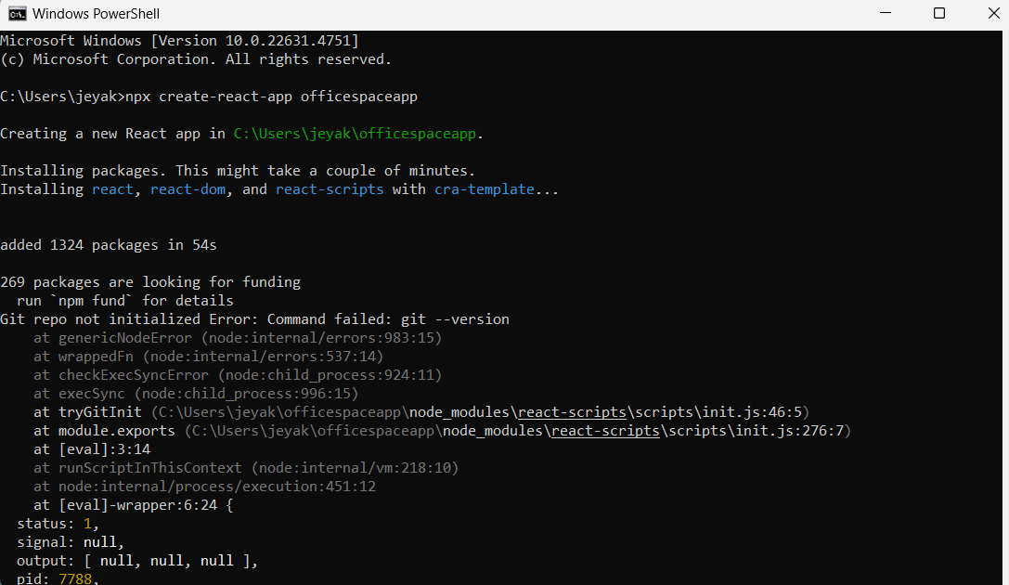

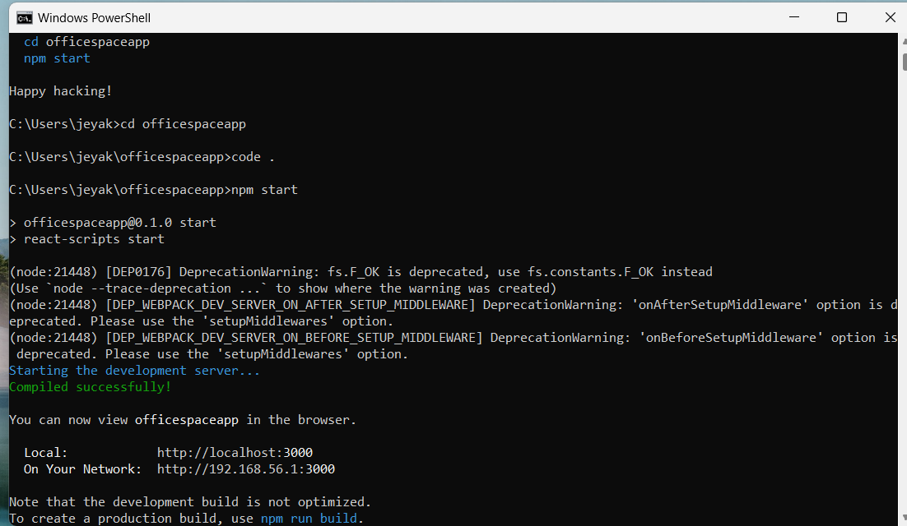

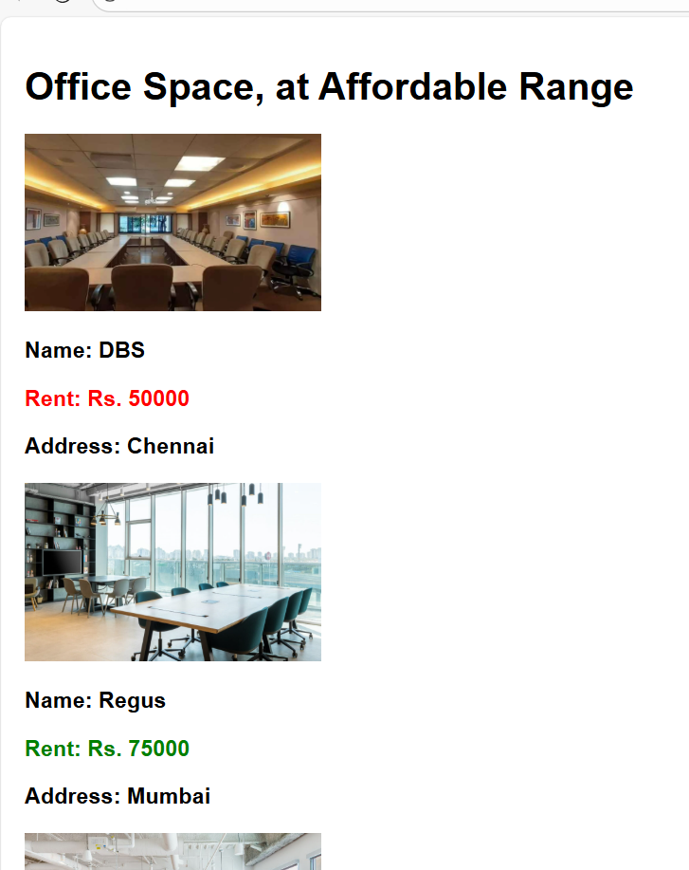

**Create a React Application “eventexamplesapp” to handle various events of the form elements in HTML.**

**CurrencyConverterApp.js**

import React, { useState } from 'react';

function CurrencyConverterApp() {

  const [count, setCount] = useState(5);

  const [amount, setAmount] = useState('');

  const [currency, setCurrency] = useState('');

  const increment = () => setCount(count + 1);

  const decrement = () => setCount(count - 1);

  const sayWelcome = (msg) => {

    alert(msg); };

  const handleClick = () => {

    alert("I was clicked");};

  const handleSubmit = () => {

    if (currency.toLowerCase() === "euro") {

      const converted = amount * 80; // 1 Euro = ₹80

      alert(`Converting to Euro Amount is ${converted}`);

    } else if (currency.toLowerCase() === "rupee" || currency.toLowerCase() === "rs") {

      const converted = amount / 80; // ₹ to Euro

      alert(`Converting to Rupee Amount is ${converted}`);

    } else {

      alert("Invalid currency. Use 'Euro' or 'Rupee'");}};

  return (

    <div style={{ padding: '20px' }}>

      <h3>{count}</h3>

      <button onClick={increment}>Increment</button>&nbsp;

      <button onClick={decrement}>Decrement</button>&nbsp;

      <button onClick={() => sayWelcome("welcome")}>Say welcome</button>&nbsp;

      <button onClick={handleClick}>Click on me</button>

      <h2 style={{ color: 'green' }}>Currency Convertor!!!</h2>

      <div>

        <label>Amount: </label>

        <input

          type="number"

          value={amount}

          onChange={(e) => setAmount(e.target.value)}

        />

      </div>

      <br />

      <div>

        <label>Currency: </label>

        <input

          type="text"

          value={currency}

          onChange={(e) => setCurrency(e.target.value)}

        />

      </div>

      <br />

      <button onClick={handleSubmit}>Submit</button>

    </div>);

}

export default CurrencyConverterApp;

**App.js**

import React from 'react';

import CurrencyConverterApp from './CurrencyConverterApp';

function App() {

  return (

    <div className="App">

      <CurrencyConverterApp />

    </div>);

}

export default App;

**index.js**

import React from "react";

import ReactDOM from "react-dom/client";

import App from "./App";

const root = ReactDOM.createRoot(document.getElementById("root"));

root.render(<App />);

**Output**

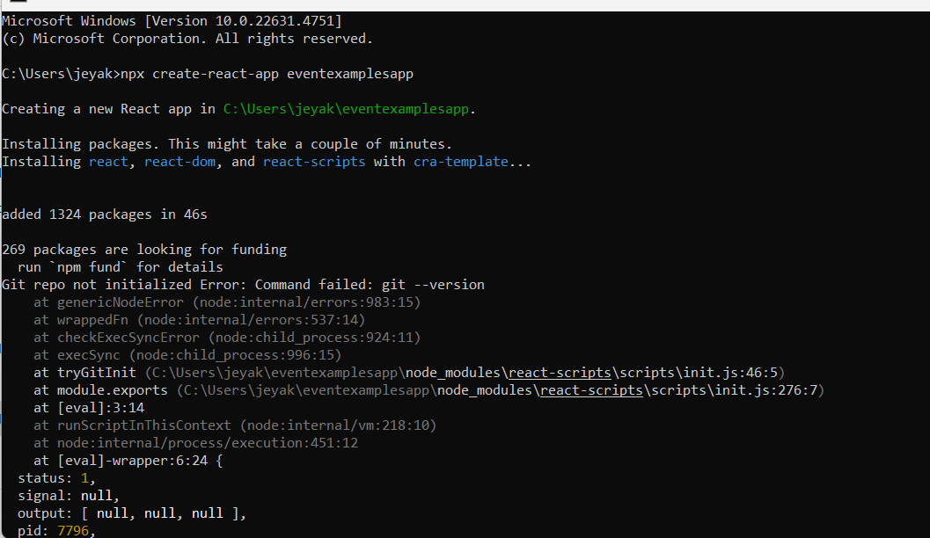

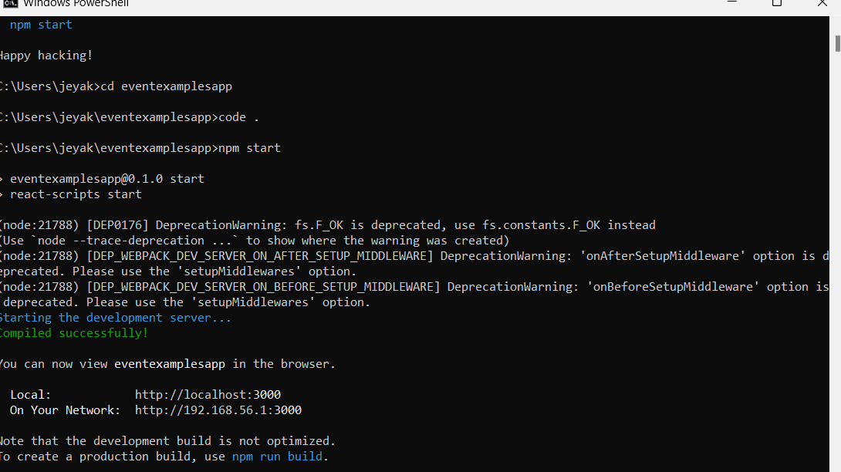

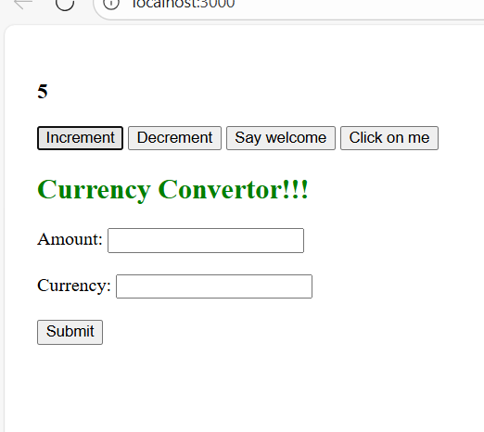

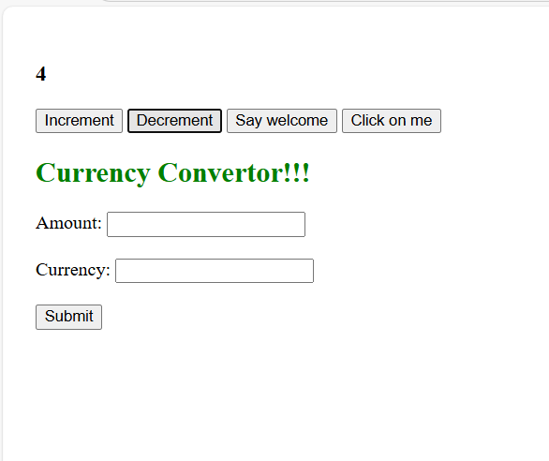

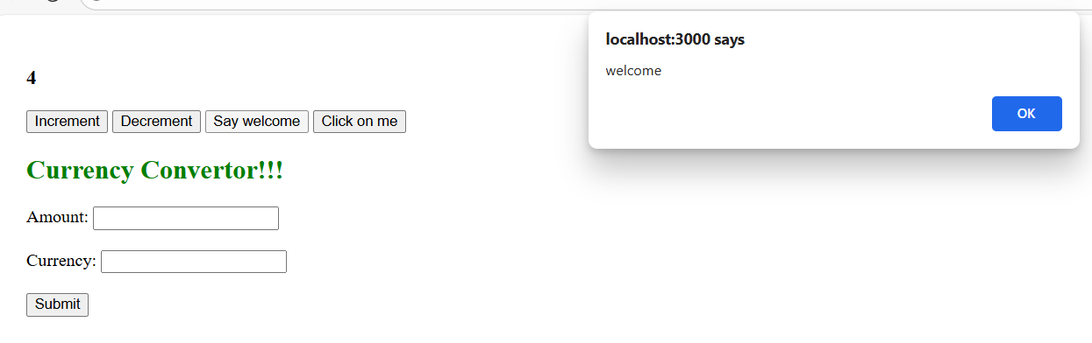

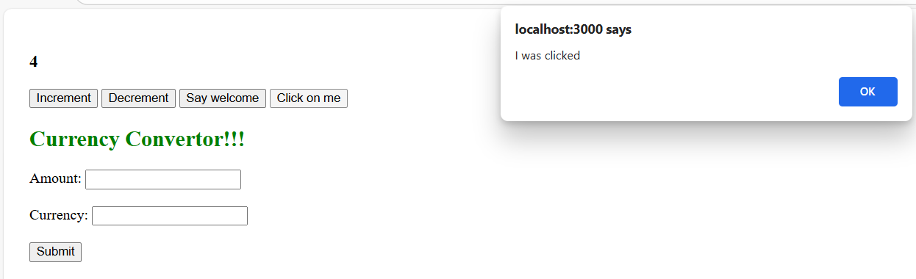

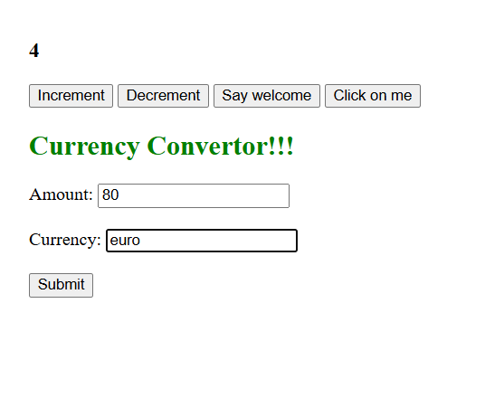

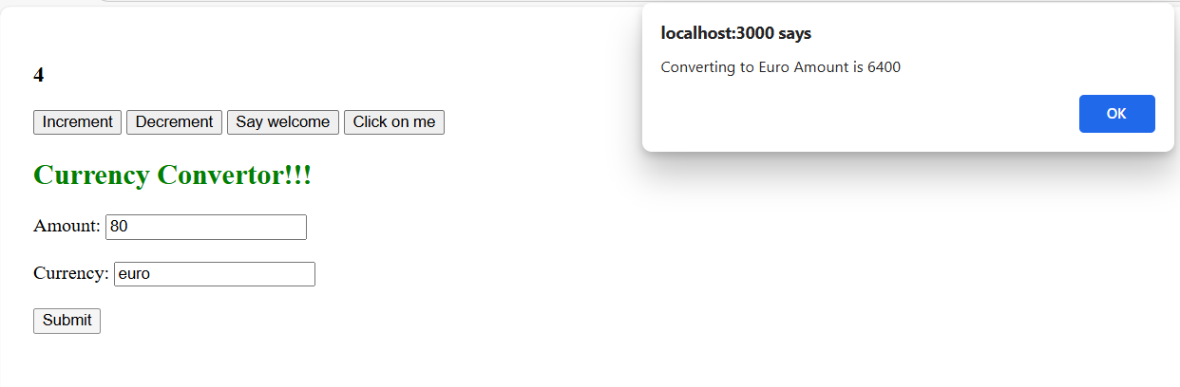

**Create a React Application named “ticketbookingapp” where the guest user can browse the page where the flight details are displayed whereas the logged in user only can book tickets.The Login and Logout buttons should accordingly display different pages. Once the user is logged in the User page should be displayed. When the user clicks on Logout, the Guest page should be displayed.**

**App.js**

import React, { useState } from 'react';

function LoginButton(props) {

  return (

    <button onClick={props.onClick}>

      Login

    </button> );

}

function LogoutButton(props) {

  return (

    <button onClick={props.onClick}>

      Logout

    </button> );

}

function UserGreeting() {

  return <h1>Welcome back</h1>;

}

function GuestGreeting() {

  return <h1>Please sign up.</h1>;

}

function Greeting(props) {

  const isLoggedIn = props.isLoggedIn;

  if (isLoggedIn) {

    return <UserGreeting />;

  }

  return <GuestGreeting />;

}

function App() {

  const [isLoggedIn, setIsLoggedIn] = useState(false);

  const handleLoginClick = () => setIsLoggedIn(true);

  const handleLogoutClick = () => setIsLoggedIn(false);

  let button;

  if (isLoggedIn) {

    button = <LogoutButton onClick={handleLogoutClick} />;

  } else {

    button = <LoginButton onClick={handleLoginClick} />;

  }

  return (

    <div>

      <Greeting isLoggedIn={isLoggedIn} />

      {button}

    </div>);

}

export default App;

**Output**

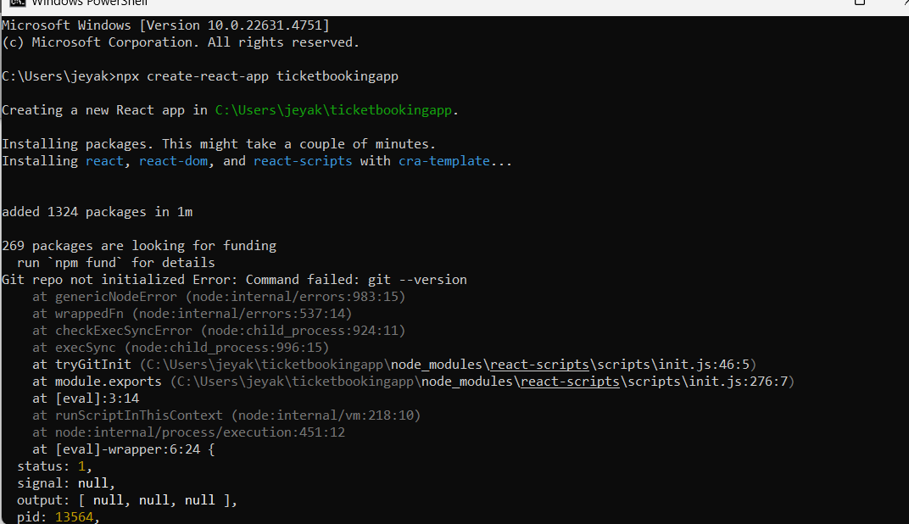

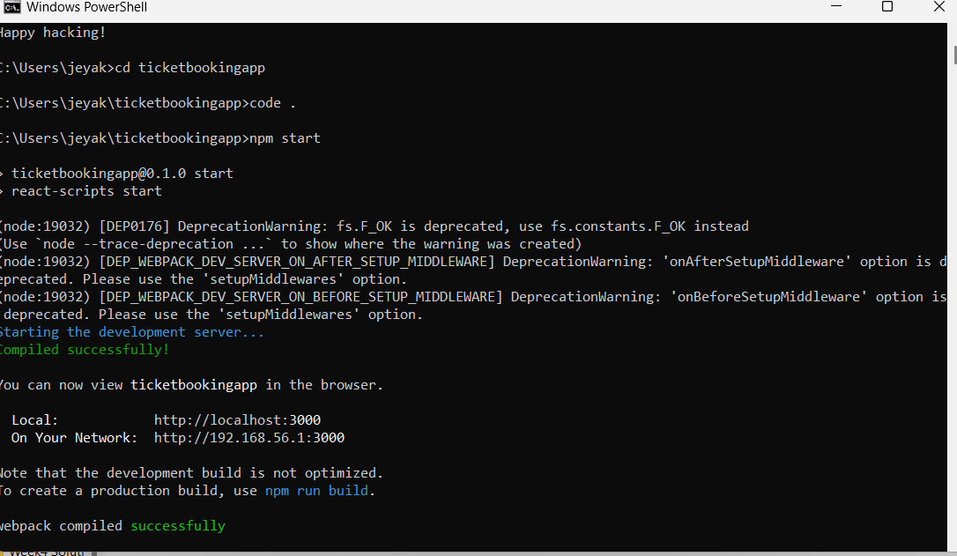

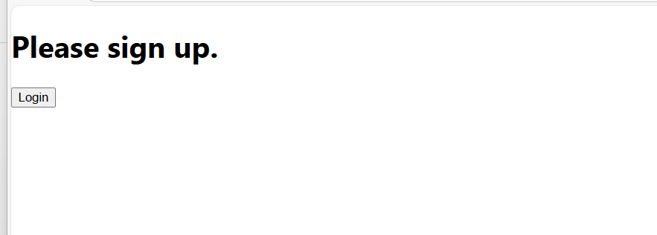

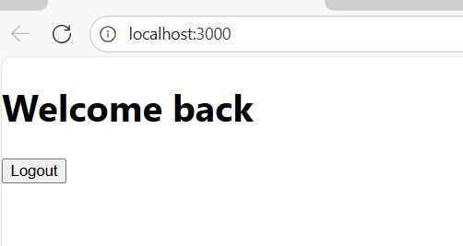

**Create a React App named “bloggerapp” in with 3 components.**

1. **Book Details**
2. **Blog Details**
3. **Course Details**

**Implement this with as many ways possible of Conditional Rendering.**

**App.js**

import React from 'react';

import './App.css';

const books = [

  { id: 101, bname: 'Master React', price: 670 },

  { id: 102, bname: 'Deep Dive into Angular 11', price: 800 },

  { id: 103, bname: 'Mongo Essentials', price: 450 },];

const blogs = [

  { id: 1, title: 'React Learning', author: 'Stephen Biz', content: 'Welcome to learning React!' },

  { id: 2, title: 'Installation', author: 'Schwerdenier', content: 'You can install React from npm.' },];

const courses = [

  { id: 1, name: 'Angular', date: '4/5/2021' },

  { id: 2, name: 'React', date: '6/7/2020' },];

const BookDetails = ({ books }) => (

  <div className="st2">

    <h1>Book Details</h1>

    <ul>

      {books.map(book => (

        <div key={book.id}>

          <h3>{book.bname}</h3>

          <h4>{book.price}</h4>

        </div>

      ))}

    </ul>

  </div>);

const BlogDetails = ({ blogs }) => (

  <div className="v1">

    <h1>Blog Details</h1>

    {blogs.map(blog => (

      <div key={blog.id}>

        <h3>{blog.title}</h3>

        <p><strong>{blog.author}</strong></p>

        <p>{blog.content}</p>

      </div>))}

  </div>);

const CourseDetails = ({ courses }) => (

  <div className="mystyle1">

    <h1>Course Details</h1>

    {courses.map(course => (

      <div key={course.id}>

        <h3>{course.name}</h3>

        <p>{course.date}</p>

      </div> ))}

  </div>);

function App() {

  return (

    <div className="container">

      <div className="section">

        <CourseDetails courses={courses} />

      </div>

      <div className="section">

        <BookDetails books={books} />

      </div>

      <div className="section">

        <BlogDetails blogs={blogs} />

      </div>

    </div>);

}

export default App;

**App.css**

.container {

  display: flex;

  justify-content: space-around;

  align-items: flex-start;

  margin-top: 30px;

  font-family: Arial, sans-serif;

}

.section {

  border-left: 3px solid green;

  padding-left: 20px;

  width: 30%;

}

.section h1 {

  font-size: 22px;

  border-bottom: 1px solid #ccc;

  padding-bottom: 5px;

  margin-bottom: 15px;

}

.section h3 {

  margin: 10px 0 5px;

}

.section h4,

.section p {

  margin: 0 0 10px;

}

**Output**

